



EDMONSON CO. FAIR

**4-H YOUTH CONTESTS** & **RULES**

**EDMONSON CO.**



# FAIR

## CUPCAKE WARS CONTEST

**September 3rd, 2024 Check-in – 5:00 p.m. Contest - 5:30 p.m.**

**Exhibit Barn**

**Any 4-H age youth 8-18 may enter the junior or senior competition.**

**A champion and a reserve champion will be selected for junior and senior categories.**

**Round Theme- County Fair**

1. Each team will consist of only 2-3 bakers.
2. Teams will have 1 hour for completion of each cupcake design. Designs must meet the theme requirements above. The team will work together for the duration of the event. All entries will be completed and submitted for the first cupcake round respectively. Awards will be presented following the firs round of judging.
3. Materials provided by the Extension Office for all teams to use:
   1. One table with access to electrical outlets will be provided for each team.
   2. A 6-count cupcake baker.
4. All participants are required to use the provided 6-count cupcake baker.
5. Cupcake Teams MUST bring all supplies needed for the 1 cupcake round. The only supplies provided are listed above in rule #4. Teams should plan on bringing ALL baking ingredients and equipment they will need, including plates, trays, or a creative item to present your cupcakes to the judges.
6. Cupcake Teams are to make their cupcakes and icing from scratch (homemade) recipes. If decorative items (e.g. elaborate fondant flowers, chocolate work that requires specialized equipment, etc.) are made in advance, teams are to bring photo documentation to provide to the judges during their presentation.
7. A wash station will NOT be provided. Participants must bring a set of utensils, bowls, and other equipment for each of the 1 cupcake round OR participants can bring a bucket/tote, water, and dish soap to wash equipment between baking rounds. Participants are NOT allowed to wash dishes or equipment in the restrooms at the Edmonson Co. Fairgrounds. If teams violate this rule, they will be disqualified.
8. Open heat sources (e.g. hot plates, torches, butane burners, etc.) are NOT allowed.
9. During the competition, participants are NOT allowed to receive help from family, friends, and the general public. Non-competitors are spectators and CANNOT participate or provide assistance, which includes but are not limited to: coaching, providing additional supplies/equipment, and washing participants’ equipment. Any violations will result in the team’s disqualification.
10. Only competitors, judges, and State Cupcake Wars Committee members are allowed inside the competition area. Family and friends of competitors are asked to respect the competition space and not block walk ways, move barriers, or lean over the barriers into competition space. Competitors are asked to stay in the competition area throughout the duration of the challenge.
11. Teams are judged on display, communication, teamwork, taste, creativity, and kitchen safety

/cleanliness. Presentation includes 1) the plating / display of the cupcake and 2) the team’s presentation. Teams should be prepared to speak to the judges and 1) introduce themselves and 2) explain their cupcake recipe and design. Communication: speaking with judges throughout competition – describing cupcake baking process and design (knowledge of the cupcakes, the recipe, inspiration, member responsibilities), as well as presenting to the judges. Display: creativity in how the cupcakes are displayed for the judges.

1. Clean-up times is included in your 1-hour challenge time. You will be scored on your cleanliness throughout the competition and your clean-up. If judges see a severe health or safety violation, judges can refuse to taste the team’s cupcake. Any team with a severe health or safety violation will receive 0 points for kitchen safety / cleanliness.

**EDMONSON CO.**



# FAIR

## BBQ CONTEST

**September 5th, 2024 check-in – 5:30 p.m. Contest - 6:00 p.m.**

**outside of the exhibit barn**

**Any 4-H age youth 9-18 may enter the competition.**

**A first, second, and third will be selected for all 3 categories: poultry, pork, beef.**

* 1. Each competitor will compete individually.
  2. Participants will be scored for cooking skills and sensory evaluation.
  3. There will be a 1-hour time limit for the preparation of all barbecue entries. One point will be deducted for every five minutes late.
  4. Fires and coals can be lit prior to the start of the event but not before the participant has registered at 6:00pm.
  5. Parboiling and/or deep-frying competition meat is not allowed.
  6. Barbecue grills will be provided for all contestants, which they will be required to use. Each contestant will be assigned a cooking space and grill along with a work area of one-half of an approximately 30-inch by 8-foot folding table adjacent to their grill.
  7. Contestants will bring their own MEAT, charcoal and lighter fuel, but self-starting charcoal or automatic fire starter blocks will not be permitted.
  8. Chimney-starters may be used, but such devices must be placed inside the grill before and during ignition and removed from the grill prior to the addition of the meat for cooking. Fire is restricted to inside the provided grill. Burning materials outside the grills will be considered a fire hazard. and you will be disqualified.
  9. The use of non-charcoal combustible fuel is to be limited. Accessories such as spits, augers, or forced drafts are not permitted. Electricity will not be provided or cannot be used. Material may not be added to the grill area such as rocks, sand, or other dense materials to aid in cooking.
  10. All other equipment and supplies, including sauce, must be furnished by the contestant. Sauce, if used, may be a commercial product or private recipe (description must be provided to judges on the recipe card to assist during flavor and appearance evaluation).
  11. Contestants are expected to use a meat thermometer. Devices used for supporting, containing, or covering meat during cooking will not be permitted; only aluminum foil wrap may be used.

Minimum meat temperatures in degrees Fahrenheit:

* + 1. -Beef Steak: 145; Ground: 160 -Poultry: 165 -Pork: 145; Ground: 160
  1. Contestants must provide recipe or preparation outline cards describing sauce, rubs, or other treatments associated with the cooking of the meat to include ingredients and special instructions if necessary, for food safety, relating to these ingredients such as keeping sauce ingredients either cool or heated.
  2. Recipe cards need to include the following information: a.-Name of the recipe and contestant number.

b.-Ingredients and general cooking instructions.

c.-If special cooking techniques were used to achieve unique flavoring.

* 1. Each contestant will present each judge with one piece of meat on plates or containers provided.
  2. The contestant is to have turned in the product by the end of the stated cooking time. Contestants will be notified 15 minutes prior to the end of the cooking time.
  3. Cooking skills will be evaluated using the cooking skills score sheets.
  4. No garnishes, dips, or additional items shall be presented on the plates or submitted to the judges.

*Entries become property of the Edmonson County 4-H and may not be returned to the participants.*

**EDMONSON CO.**



# FAIR

## BAKING CONTEST

**September 3rd, 2024**

**Check-in – 5:30 to 7:00 p.m.**

**Judging- 7:00 p.m. exhibit barn**

**Any 4-H age youth 9-18 may enter the competition. Cloverbud division for those 8 & under.**

**A first, second, and third will be selected for all 3 categories: Fried Pies, Cobbler, Cookies, Sweet treats.**

1. Entries will be prepared ahead of time and brought to the fairgrounds for judging.
2. Entries will be judged upon the following categories: a.appearance

b.taste

c.technique d.neatness

1. Entries become property of the Edmonson County 4-H and may not be returned to the participants. 4. Participants serving dishes will be returned, please label accordingly.

## FASHION REVUE

**September 3rd, 2024**

**check-in– 5:30 to 6:00 p.m.**

**Show - 6:00 p.m. exhibit barn**

**Any 4-H age youth 9-18 may enter the competition.**

**Cloverbud division for those 8 & under.**

**A first, second, and third will be selected for all 4 categories:**

**Sew Your Own, Career, Hobby, Pick your own, and Edmonson County boutique spotlight.**

Entries will be prepared ahead of time and brought to the fairgrounds for the fashion revue. Entries will be judged upon the following categories:

originality

category theme followed outfit cohesiveness

Please have the following information on a separate sheet of paper with you ahead of time to provide at registration for our emcee during the fashion revue. Please have one for each outfit entered into a category:

Name

Parents/ Guardians Names School Grade

What are your hobbies? School Activities

4-H Activities

Church & Community Activities Your favorite place on earth?

What are your future plans?

Give a description of your outfit( fabric, style, color, how many pieces, accessories, etc.)

**EDMONSON CO.**

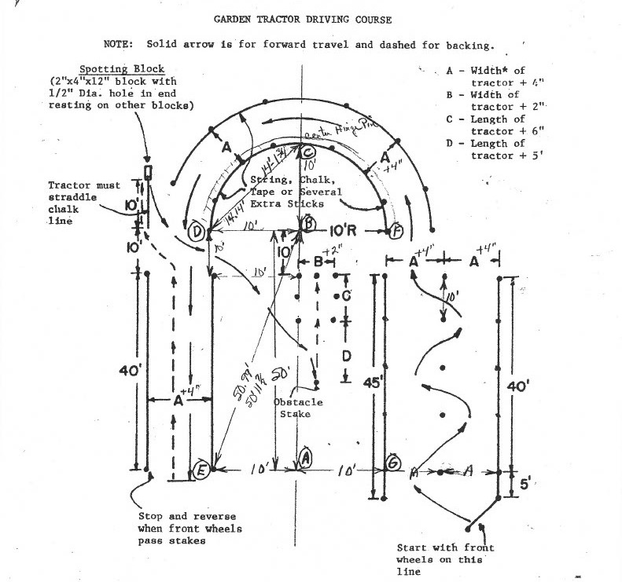

# FAIR

## LAWN TRACTOR DRIVING CONTEST

**September 3rd, 2024**

**Check-in – 5:30 to 6:00 p.m.**

**Contest- 6:00 p.m. arena**

**Any 4-H age youth 9-18 may enter the competition.**

**Cloverbud division for those 5-8.**

**A first, second, and third will be selected for junior and senior categories.**

**Cloverbuds will receive ribbons only.**

1. Cloverbuds will bring their own battery operated riding yard toy for the course.
2. No motorized toys will be allowed.
3. Entries will be judged upon the following categories:
   1. successful completion of the course
   2. number of infractions: hitting obstacles, knocking over obstacles, etc.
   3. pattern correctness
   4. time to complete course
   5. clutch use and gear-grinding
   6. safety
4. Junior and senior contestants will be using a zero-turn mower with the blades removed. 5.Contestants need a prior knowledge of zero-turn mowers before the contest.

6.Any contestant deemed not safe during the contest will be disqualified.

**EDMONSON CO.**



# FAIR

## LEGENDARY LEGOS CONTEST

**September 3rd, 2024 Project Check-In – 5:00 pm.**

**Judging- 6:30 p.m. exhibit barn**

**contest Theme: County Fair**

**Any age youth 5-18 may enter the competition. Junior, Senior, and Cloverbud divisions.**

**A first, second, and third will be selected for both categories in each division: Build from a kit and Build not from a kit.**

1. Entries will be prepared ahead of time and brought to the fairgrounds for judging.
2. Entries will be judged upon the following categories: a.originality

b.concept easily identified c.techniques used

d.neatness

1. Entries may use Legos or any similar type blocks for their build.
2. Entries will be picked back up after the contest has been judged and are eligible to be an entry into the 4-H Exhibit Barn on Thursday September 5th.

**EDMONSON CO.**



# FAIR

## 4-H POULTRY PULLET SHOW

**September 7th, 2024 check-in – 9:00 am. Show- 9:30 a.m. lower barn**

**Any 4-H age youth 5-18 may enter the competition.**

**A first and second place will be selected for all categories in each division and Grand and Reserve Champion from them all.**

1. All animals must be contained or restrained while on the fairgrounds.
2. Cages for entries will be provided.
3. Participants are limited to one bird per category.
4. Entries will be judged upon the following categories:
   1. Cloverbud
      1. Standard-size or bantam 1.Showmanship
   2. Junior
      1. Standard-size or bantam 1.Showmanship
   3. Senior
      1. Standard-size or bantam 1.Showmanship

## FUN PET & LIVESTOCK SHOW

**September 7th, 2024 check-in – 9:00 am. Show- 10:00 a.m.**

**between the arena and concessions**

**Any 4-H age youth 5-18 may enter the competition.**

**A first place will be selected for all categories in each division and a Best Overall:**

*Domestic(Pet) and Farm*

1. All animals must be contained or restrained on a leash while on the fairgrounds.
2. Entries will be judged upon the following categories:
   1. Most Unusual Pet
   2. Best Groomed c.Friendliest Pet
3. Largest Pet
4. Best Trick Act
5. Best Costume
6. Biggest Ears
7. Longest Tail